|  |  |  |  |
| --- | --- | --- | --- |
| \\lyng-dc1\StaffShared\Learning Bugs Animals ALL subjects\characters bugs animals\Cyril the Snail - History.jpeg**Lyng Primary School Knowledge Organiser** | | | |
| **History Topic:** | **Let’s Remember**  **What dates and events are importand during World War One?** | Year 2  *Let’s Remember* | Summer |

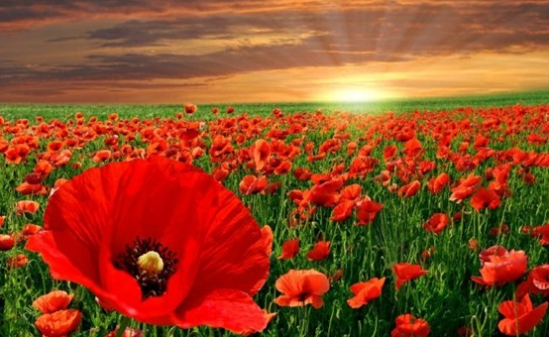

**Background information for parents and teachers**

World War I began in 1914, after the assassination of Archduke Franz Ferdinand, and lasted until 1918. During the conflict, Germany, Austria-Hungary, Bulgaria and the Ottoman Empire (the Central Powers) fought against Great Britain, France, Russia, Italy, Romania, Japan and the United States (the Allied Powers).  By the time the war was over and the Allied Powers claimed victory, more than 16 million people, soldiers and civilians alike were dead.

|  |  |
| --- | --- |
| **What Step On and Goldilocks words will I use?** | |
| **Spelling** | **Definition** |
| Allies | The powers of the Triple Entente (France, Russia and Britain) |
| Armistice | An agreement between countries who are at war with one another to stop fighting and to discuss ways of making peace. |
| Artillery | Large powerful guns, which are transported on wheels and used by army. |
| Assassinate | Someone important is killed as a political act. |
| Battle | A violent fight between groups of people, especially one between military forces during a war. |
| Enemy | An army or other force that is opposed to you in a war, or a country with which your country is at war. |
| Trench Warfare | A type of warfare in which opposing armies face each other in entrenched positions. |

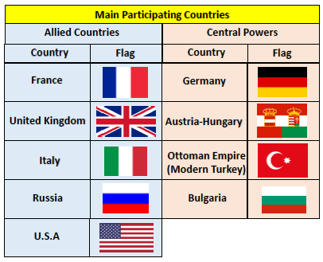

|  |  |
| --- | --- |
| **When? (Timeline of key events)** | |
| June 28th 1914 | Archduke Franz Ferdinand is assassinated by Serbian Terrorist. |
| July 28th 1914 | Austria-Hungary declares War on Serbia. |
| August 1914 | Germany Declares War on Russia in support of Austria-Hungary before declaring War on France. Following a German invasion of Belgium, Britain declares war on Germany. |
| September 1914 -throughout | Trench Warfare begins with only tiny gains achieved. |
| December 24th 1914 | The Christmas Truce |
| February 1915 – Jan 1916 | Battle of Gallipoli |
| July 1916 – Nov 1916 | Battle of the Somme |
| December 1917 | Russia leaves War. |
| November 11th 1918 | Armistice is agreed. Germany admit defeat at the end of the War. Guns fall silent at 11am. |

**Hook (LOtC)**

Outdoor learning in Trenches. Hot seat a soldier being sent off to war.



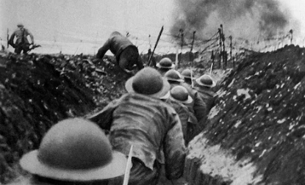

c

**TRIP/VISITOR**

Visit to West Bromwich Colleigate to use their immersive room.



**Havelock Ellis** – “There is nothing that war has ever achieved that we could not better achieve without it.”

**Great Quotes**

**Focus Text**

**Our Storytelling Approach to enhance engagement**

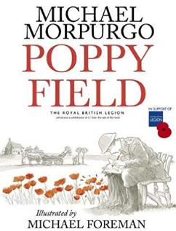

|  |  |  |
| --- | --- | --- |
| **People:**  Young, British Soldier | **Place:**  The Western Front | **Problem:**  British Soldier being sent off for battle. |

**Key Facts and Famous Figures**

• World War 1 began on July 28, 1914 and lasted until November 11, 1918

• The two main sides were the Allies, which included France, Great Britain and Russia; and Germany and Austria-Hungary

• In total, 30 countries were involved in the conflict. Italy, once part of the Triple Alliance with Germany and Austria-Hungary, fought on the side of the Allies.

• Soldiers fought largely in trenches during the war, and thousands suffered from stress, known as shell-shock.

* • By the end of WW1, over 9 million soldiers had been killed, and another 21 million wounded. Over a million soldiers were killed in the infamous Battle of the Somme alone, including about 30,000 in just one day.
* • During World War 1, dogs were used to carry messages in capsules attached to their body. Dogs also carried and placed telegraph wires in important areas.
* • Cannons and artillery were often extremely loud. In 1917, the explosives used to destroy a bridge in France could be heard over 130 miles away in London.
* • Walter Tull was an English footballer who played for Northampton Town and Tottenham Hotspur. He was also the first black officer in the British army and fought in [World War 1](http://primaryfacts.com/1645/world-war-1-facts-and-information/).
* Wilfred Owen fought during World War 1 and wrote poems about his experience.
* • Sargent Stubby is an army dog that served for 18 months and participated in 17 battles during World War 1.

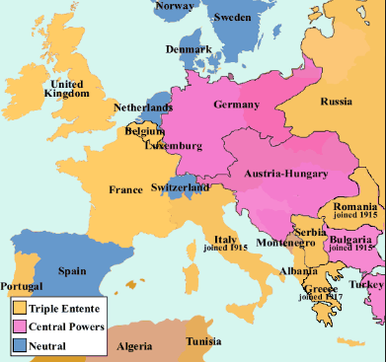

**Key skills – Taken from Milestone 1 – Sequence of Learning**

**Agreed Outcome**

* Re-enactment of Trench Warfare in the outdoor trenches.
* Letter written to show understanding of historical artefacts.
* Fact file about Walter Tull and his importance in British history.

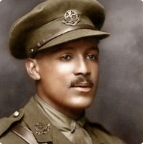

* What events took place during World War One?
* What were different artefacts used for in WW1?
* What did a World War One soldier carry in their kit bag?
* Who was Walter Tull?
* How was WW1 different to previous war?
* What happened during the battle of the Somme?

* What is Remembrance Day and why do we have it?

|  |  |  |  |
| --- | --- | --- | --- |
| \\lyng-dc1\StaffShared\Learning Bugs Animals ALL subjects\characters bugs animals\Cyril the Snail - History.jpeg**Lyng Primary School Knowledge Quiz** | | | |
| **History Topic:** | **Significant events during WWI** | Year 2  Let’s Remember | Summer |

|  |  |  |
| --- | --- | --- |
| 6. Where did most of the fighting take place? | **S** | **E** |
| Air |  |  |
| Trenches |  |  |
| Sea |  |  |

|  |  |  |
| --- | --- | --- |
| 7. What grows on Flanders Field? | **S** | **E** |
| Poppies |  |  |
| Daises |  |  |
| Buttercups |  |  |

|  |  |  |
| --- | --- | --- |
| 1. What’s happened at Flanders Field? | **S** | **E** |
|  |  |  |

|  |  |  |
| --- | --- | --- |
| 1. The amount of people that died in WW1 was in the… | **S** | **E** |
| thousands |  |  |
| millions |  |  |
| hundreds |  |  |

|  |  |  |
| --- | --- | --- |
| 1. When did WW1 end? | **S** | **E** |
| 1946 |  |  |
| 1916 |  |  |
| 1918 |  |  |

|  |  |  |
| --- | --- | --- |
| 1. When did WW1 begin? | **S** | **E** |
| 1. 1917 |  |  |
| 1. 1914 |  |  |
| 1. 1939 |  |  |

**Our WW1**

**Quick Quiz**

|  |  |  |
| --- | --- | --- |
| 1. What was the cause of WW1? | **S** | **E** |
| Lack of food |  |  |
| Invasion of Poland |  |  |
| Assassination of Franz Ferdinand |  |  |

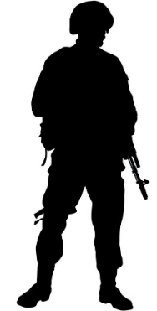

|  |  |  |
| --- | --- | --- |
| 1. Give an example of how WW1 is remembered? | **S** | **E** |
|  |  |  |

|  |  |  |
| --- | --- | --- |
| 1. Which of these was an Allied Country? | **S** | **E** |
| France |  |  |
| Germany |  |  |
| Hungary |  |  |

|  |  |  |
| --- | --- | --- |
| 1. Which of these was a part of the Central Powers | **S** | **E** |
| United Kingdom |  |  |
| Italy |  |  |
| Germany |  |  |